**DATABASE MANAGEMENT SYSTEMS LAB-MANUAL**

1.Consider the relations

EMPLOYEE(SSN, Name, DeptNo),

ASSIGNED_TO(USN , ProjectNo)

PROJECT(ProjectNo, ProjectArea).

Create the above tables, insert suitable tuples and perform the following operations in SQL:

1. Obtain the SSN of employees assigned to database projects.
2. Find the number of employees working in each department
3. Update the ProjectNo of Employee bearing SSN=1 to ProjectNo=20

SOLUTION:

LINK TO THE SQLFIDDLE:- <http://sqlfiddle.com/#!9/365bfa/1/4>

**CREATING TABLE EMP:-**

CREATE TABLE EMP (

SSN INT PRIMARY KEY,

NAME VARCHAR(25),

SEX VARCHAR(1),

SALARY INT,

DNO INT REFERENCES DEPT (DNO)

);

**CREATING TABLE PROJECT**

CREATE TABLE PROJECT (

PNO INT PRIMARY KEY,

PNAME VARCHAR(25),

DOMAIN VARCHAR(25),

DNO INT REFERENCES DEPT(DNO)

);

**CREATING TABLE WORKS_ON**

CREATE TABLE WORKS_ON (

ESSN VARCHAR(10) REFERENCES EMP(SSN),

PNO INT REFERENCES PROJECT(PNO),

HOURS INT,

PRIMARY KEY(ESSN,PNO)

);

**CREATING TABLE DEPT**

CREATE TABLE DEPT (

DNO INT PRIMARY KEY,

DNAME VARCHAR(25)

);

**INSERT ELEMENTS TO EMP**

INSERT INTO EMP VALUES(123456789,'ADITYA','M',25000,2);

INSERT INTO EMP VALUES(333444555,'ANJALI','F',30000,3);

INSERT INTO EMP VALUES(999888777,'ANANYA','F',42000,1);

INSERT INTO EMP VALUES(664422555,'AKSHAT','M',52000,1);

INSERT INTO EMP VALUES(987654321,'AMAR','M',40000,2);

**INSERT ELEMENTS TO PROJECT**  
INSERT INTO PROJECT VALUES(1,'DATABASE','DBMS',1);

INSERT INTO PROJECT VALUES(2,'CLOUD COMPUTING','IT',2);

INSERT INTO PROJECT VALUES(3,'REORGANISATION','ANDROID DEVELOPMENT',2);

INSERT INTO PROJECT VALUES(4,'NEWBENEFITS','CAED',3);

**INSERT ELEMENTS TO WORKS_ON**  
INSERT INTO WORKS_ON VALUES(123456789,1,25);

INSERT INTO WORKS_ON VALUES(123456789,2,2);

INSERT INTO WORKS_ON VALUES(333444555,2,16);

INSERT INTO WORKS_ON VALUES(333444555,1,10);

INSERT INTO WORKS_ON VALUES(664422555,3,18);

INSERT INTO WORKS_ON VALUES(664422555,1,8);

INSERT INTO WORKS_ON VALUES(999888777,2,28);

INSERT INTO WORKS_ON VALUES(987654321,2,14);

INSERT INTO WORKS_ON VALUES(987654321,3,4);

**INSERT ELEMENTS TO DEPT**

INSERT INTO DEPT VALUES(1,'COMPUTER SCIENCE');

INSERT INTO DEPT VALUES(2,'INFORMATION SCIENCE');

INSERT INTO DEPT VALUES(3,'MECHANICAL');

**SELECT * FROM EMP;**

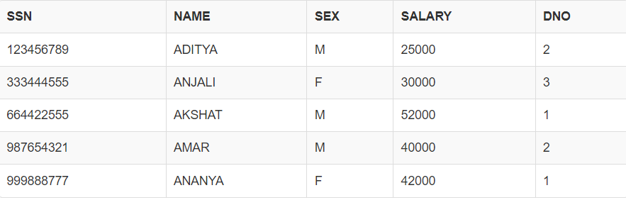

**SELECT * FROM PROJECT;**

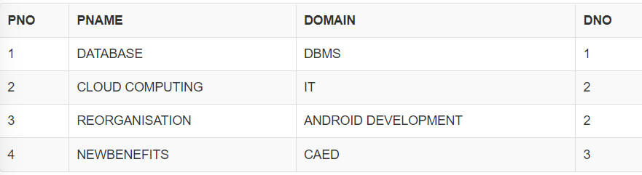

**SELECT * FROM WORKS_ON;**  
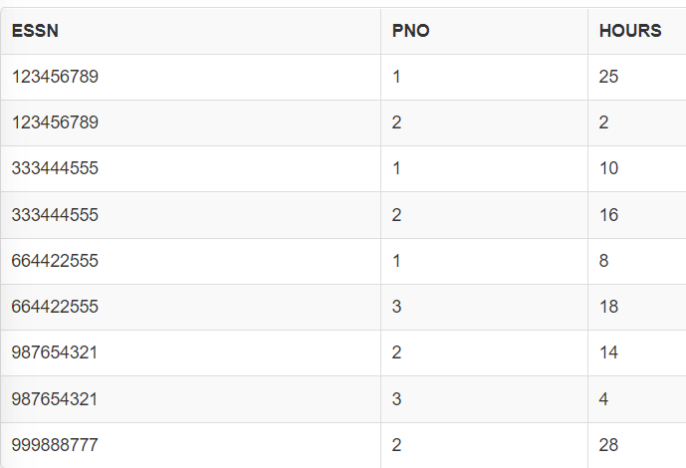

**SELECT * FROM DEPT;**

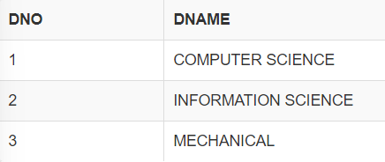

SELECT * FROM EMP

WHERE SSN IN ( SELECT ESSN FROM WORKS_ON

WHERE PNO IN (SELECT PNO FROM PROJECT

WHERE PNAME = 'DATABASE'));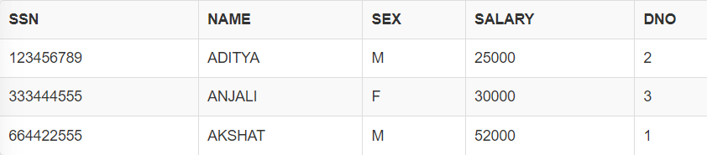  
  
SELECT E.DNO,DNAME,COUNT(SSN) AS TOTAL_EMPLOYEE FROM EMP E,DEPT D

WHERE E.DNO=D.DNO

GROUP BY E.DNO;  
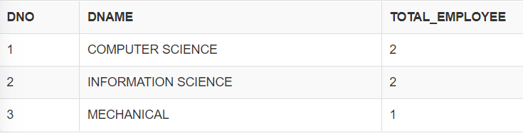  
UPDATE WORKS_ON

SET PNO = 10

WHERE ESSN = 123456789 and PNO=2;

UPDATE STATEMENT WILL BE EXECUTED ONLY WHEN EITHER BOTH USN AND PROJECTNO IS INCLUDED IN THE WHERE STATEMENT OR ONLY USN IS INCLUDED IN THE WHERE STATEMENT (THE ONLY CONDITION IS THAT USN IS ABLE TO DISTINGUISH IT FROM ALL THE TUPLES PRESENT IN THE WORKS_ON TABLE) IS UNIQUE IN THE WORKS_ON TABLE

2. Consider the relations

PART(PNO, PNAME, COLOUR),

SUPPLIER( SNO,SNAME,ADDRESS)

SUPPLY(PNO,SNO,QUANTITY)

Create the above tables, insert suitable tuples and perform the following operations in SQL:

1. Obtain the details of parts supplied by supplier #SNAME.

2. Obtain the Names of suppliers who supply #PNAME.

e) Delete the parts which are in #PCOLOR.

SOLUTION:

LINK TO THE SQLFIDDLE:- <http://sqlfiddle.com/#!9/5f75fb/1/0>

**CREATING TABLE SUPPLIER**

CREATE TABLE SUPPLIER (

SID INT PRIMARY KEY,

SNAME VARCHAR(25),

SADDRESS VARCHAR(20)

);

**CREATING TABLE PART**  
CREATE TABLE PART (

PID INT PRIMARY KEY ,

PNAME VARCHAR(25),

PCOLOR VARCHAR(15)

);  
**CREATING TABLE SUPPLY**

CREATE TABLE SUPPLY (

SID INT REFERENCES SUPPLIER (SID) ON DELETE CASCADE,

PID INT REFERENCES PART (PID) ON DELETE CASCADE,

QUANTITY INT,

PRIMARY KEY(SID,PID)

);

**INSERT ELEMENTS TO PART**  
INSERT INTO PART VALUES(1,'PUMA SHOES','PINK');

INSERT INTO PART VALUES(2,'ADDIDAS SHOES','BLACK');

INSERT INTO PART VALUES(3,'SANDAL','GREY');

INSERT INTO PART VALUES(4,'RELAXO SLIPPERS','BLACK GREY');

INSERT INTO PART VALUES(5,'SUNGLASS','TRANSPARENT');

**INSERT ELEMENTS TO SUPPLIER**  
INSERT INTO SUPPLIER VALUES(100,'ADITYA','BIHAR');

INSERT INTO SUPPLIER VALUES(200,'GAURAV','DELHI');

INSERT INTO SUPPLIER VALUES(300,'ANJALI','NEPAL');

INSERT INTO SUPPLIER VALUES(400,'AGAM','BANARAS');

INSERT INTO SUPPLIER VALUES(500,'AMAR','KARNATKA');

**INSERT ELEMENTS TO SUPPLY**

INSERT INTO SUPPLY VALUES(200,1,13);

INSERT INTO SUPPLY VALUES(300,1,25);

INSERT INTO SUPPLY VALUES(100,2,65);

INSERT INTO SUPPLY VALUES(100,4,23);

INSERT INTO SUPPLY VALUES(400,8,80);

INSERT INTO SUPPLY VALUES(500,7,40);

**DISPLAYING CONTENTS OF ALL THE THREE TABLES**

**SELECT * FROM PART;**

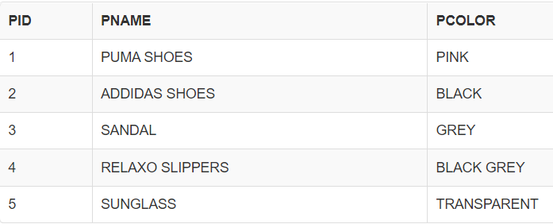

**SELECT * FROM SUPPLY ;**

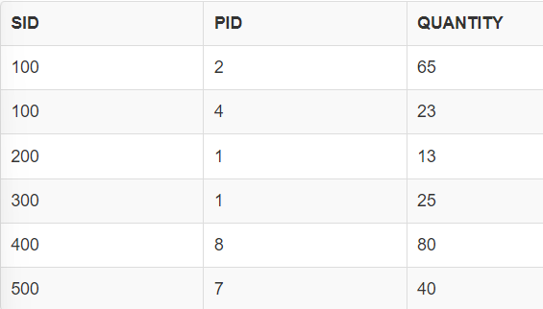

**SELECT * FROM SUPPLIER ;**  
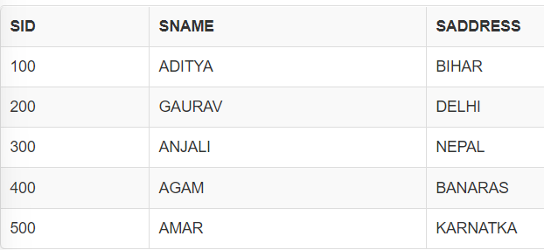

answer 2)

Obtain the details of parts supplied by supplier #SNAME.

SELECT * FROM PART

WHERE PID IN( SELECT PID FROM SUPPLY

WHERE SID IN (SELECT SID FROM SUPPLIER

WHERE SNAME = 'ADITYA'));

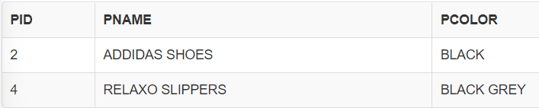

Obtain the Names of suppliers who supply #PNAME.

SELECT * FROM SUPPLIER

WHERE SID IN( SELECT SID FROM SUPPLY

WHERE PID IN (SELECT PID FROM PART

WHERE PNAME = 'PUMA SHOES'));

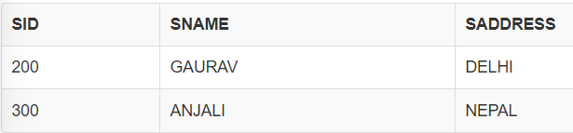

Delete the parts which are in #PCOLOR.  
DELETE FROM PART WHERE PCOLOR ='PINK';

3.Consider the relations

BOAT(BID, BNAME, BCOLOR),

SAILOR(SID, SNAME, AGE, RATING)

RESERVES(BID,SID, DAY)

Create the above tables, insert suitable tuples and perform the following operations in SQL:

1. Obtain the bid of the boats reserved by ‘Ram’.
2. Retrieve the bid of the boats reserved by all the sailors.
3. Find the number of boats reserved by each sailor

SOLUTION:

LINK TO SQL FIDDLE:- <http://sqlfiddle.com/#!9/97fd488/2/5>

**CREATING TABLE BOAT**  
CREATE TABLE BOAT (

BID INT PRIMARY KEY,

BNAME VARCHAR(25),

COLOR VARCHAR(25)

);

**CREATING TABLE SAILOR**  
CREATE TABLE SAILOR (

SID INT PRIMARY KEY,

SNAME VARCHAR(25),

AGE INT

);

**CREATING TABLE RESERVES**  
CREATE TABLE RESERVE (

BID INT REFERENCES BOAT(BID) ON DELETE CASCADE,

SID INT REFERENCES SAILOR(SID) ON DELETE CASCADE,

QUANTITY INT

);

**INSERT ELEMENTS TO BOAT TABLE**  
  
INSERT INTO BOAT VALUES (1,'BOAT1','PINK');

INSERT INTO BOAT VALUES (2,'BOAT2','BLACK');

INSERT INTO BOAT VALUES (3,'BOAT3','GREY');

INSERT INTO BOAT VALUES (4,'BOAT4','GREEN');

INSERT INTO BOAT VALUES (5,'BOAT5','YELLOW');

INSERT INTO BOAT VALUES (6,'BOAT6','RED');

**INSERT ELEMENTS TO SAILOR TABLE**

INSERT INTO SAILOR VALUES(10,'ADITYA',25);

INSERT INTO SAILOR VALUES(20,'AGAM',15);

INSERT INTO SAILOR VALUES(30,'AMAR',28);

INSERT INTO SAILOR VALUES(40,'AKSHAT',25);

INSERT INTO SAILOR VALUES(50,'ANJALI',20);

INSERT INTO SAILOR VALUES(60,'ANANYA',23);

**INSERT ELEMENTS TO RESERVE TABLE**

INSERT INTO RESERVE VALUES(1,20,5);

INSERT INTO RESERVE VALUES(2,30,41);

INSERT INTO RESERVE VALUES(3,50,9);

INSERT INTO RESERVE VALUES(4,10,4);

INSERT INTO RESERVE VALUES(5,20,8);

INSERT INTO RESERVE VALUES(5,30,18);

**SELECT * FROM BOAT ;**  
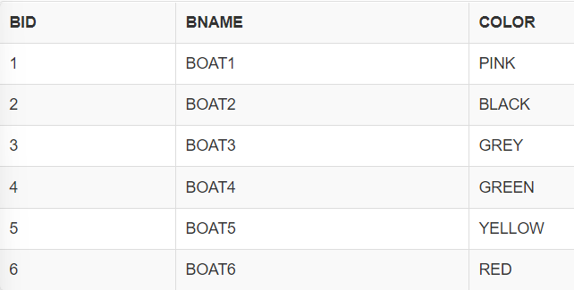  
  
**SELECT *  FROM SAILOR;**  
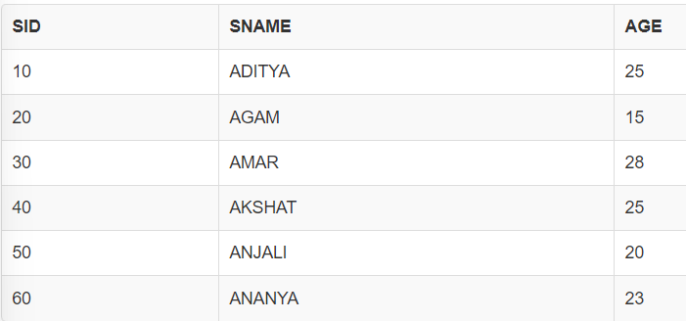

**SELECT *  FROM RESERVES ;**  
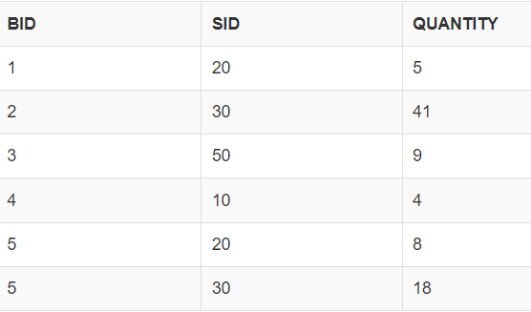  
  
  
 ans1  
  
SELECT * FROM BOAT

WHERE BID IN(SELECT BID FROM RESERVE

WHERE SID IN(SELECT SID FROM SAILOR

WHERE SNAME = 'ADITYA')); 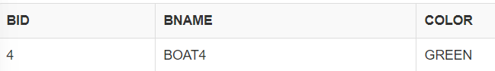

ans2

SELECT BID,SNAME FROM RESERVE R,SAILOR S

WHERE(R.SID=S.SID);

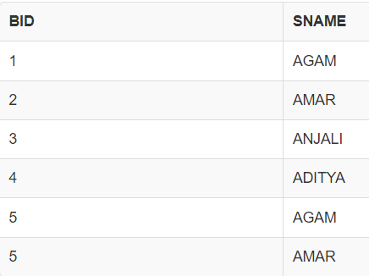

ans 3

SELECT SNAME,SUM(QUANTITY) FROM RESERVE R,SAILOR S

WHERE R.SID = S.SID

GROUP BY R.SID;

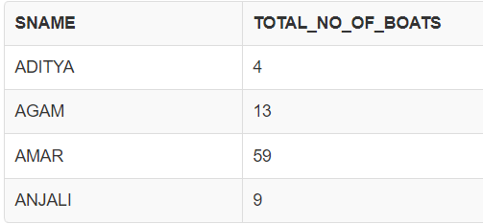

4. Consider the following database for a BANK system

BRANCH(BID, BName)

CUSTOMER(CID,Cname)

ACCOUNT(AccNo,Acctype,AccBalance,CID,BID)

TRANSACTION(Tid,Ttype,Tamount,AccNo)

SOLUTION:

LINK TO THE SQLFIDDLE:- <http://sqlfiddle.com/#!9/1ec78a/22/0>

**CREATING TABLE CUSTOMER**

CREATE TABLE CUSTOMER(

CID INT PRIMARY KEY,

CNAME VARCHAR(25)

);

**CREATING TABLE BRANCH**

CREATE TABLE BRANCH (

BID INT PRIMARY KEY,

BNAME VARCHAR(25)

);

**CREATING TABLE ACCOUNT**

CREATE TABLE ACCOUNT(

ACCOUNT_NO INT PRIMARY KEY,

ACCOUNT_TYPE VARCHAR(10),

ACCOUNT_BALANCE INT,

CUSTOMER_ID INT REFERENCES CUSTOMER(CID),

BID INT REFERENCES BRANCH(BID)

);

**CREATING TABLE TRANSACTION**

CREATE TABLE TRANSACTION (

TID INT PRIMARY KEY,

TRANSACTION_TYPE VARCHAR(25),

TRANSACTION_AMOUNT INT,

ACCOUNT_NO INT REFERENCES ACCOUNT(ACCOUNT_NO)

);

**INSERT ELEMENTS TO CUSTOMER** **TABLE**

INSERT INTO CUSTOMER VALUES(1,'ADITYA');

INSERT INTO CUSTOMER VALUES(2,'ANANYA');

INSERT INTO CUSTOMER VALUES(3,'AMAN');

INSERT INTO CUSTOMER VALUES(4,'AKSHAT');

INSERT INTO CUSTOMER VALUES(5,'AMAR');

INSERT INTO CUSTOMER VALUES(6,'AGAM');

**INSERT ELEMENTS TO BRANCH** **TABLE**

INSERT INTO BRANCH VALUES(10,'AGRA');

INSERT INTO BRANCH VALUES(20,'TAJ');

INSERT INTO BRANCH VALUES(30,'MAHAL');

**INSERT ELEMENTS TO ACCOUNT** **TABLE**

INSERT INTO ACCOUNT VALUES(100,'SAVING',10000,1,10);

INSERT INTO ACCOUNT VALUES(200,'CURRENT',30000,1,30);

INSERT INTO ACCOUNT VALUES(300,'SAVING',20000,3,20);

INSERT INTO ACCOUNT VALUES(400,'CURRENT',40000,4,20);

**INSERT ELEMENTS TO TRANSACTION** **TABLE**

INSERT INTO TRANSACTION VALUES(1000, 'DEPOSIT', 25000,100);

INSERT INTO TRANSACTION VALUES(2000, 'WITHDRAW', 45000,200);

INSERT INTO TRANSACTION VALUES(3000, 'DEPOSIT', 55000,200);

INSERT INTO TRANSACTION VALUES(4000, 'WITHDRAW', 35000,200);

INSERT INTO TRANSACTION VALUES(5000, 'DEPOSIT', 15000,400);

**SELECT * FROM CUSTOMER;**

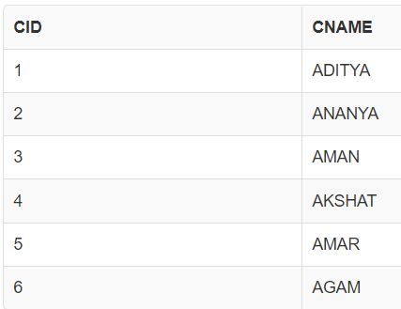

**SELECT * FROM BRANCH;**

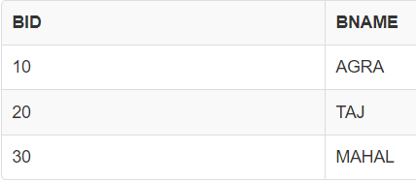

**SELECT * FROM TRANSACTION;**

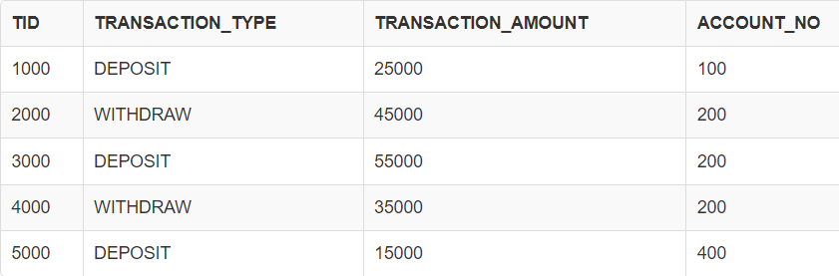

**SELECT * FROM ACCOUNT;**

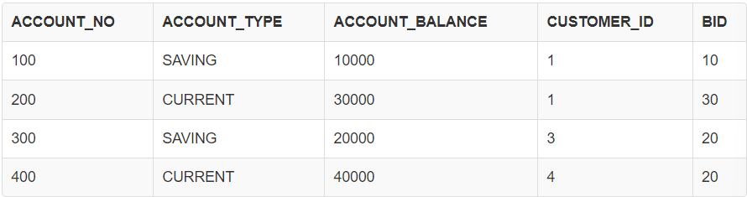  
ans a)  
SELECT * FROM CUSTOMER

WHERE CID IN (SELECT CUSTOMER_ID FROM ACCOUNT

GROUP BY CUSTOMER_ID

HAVING COUNT(CUSTOMER_ID) =2 );

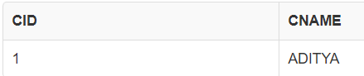

ans b)

SELECT A.BID, BNAME, COUNT(CUSTOMER_ID) AS TOTAL_CUSTOMER

FROM ACCOUNT A, BRANCH B

WHERE A.BID = B.BID

GROUP BY A.BID;  
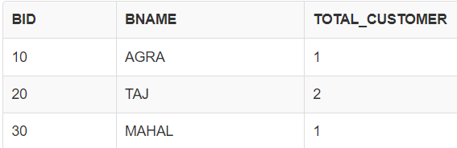

c)  
SELECT CID, CNAME from CUSTOMER

WHERE CID IN (SELECT CUSTOMER_ID FROM ACCOUNT

WHERE ACCOUNT_NO IN (SELECT ACCOUNT_NO FROM TRANSACTION

GROUP BY ACCOUNT_NO

HAVING COUNT(ACCOUNT_NO)>2));

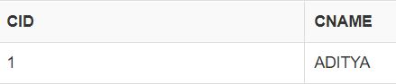

5.Consider the relations

BOOK(ISBN, TITLE,AUTHOR,PUBLISHER)

STUDENT(USN, NAME, SEM, DEPTNO),

BORROW(ISBN, USN, DATE)

Create the above tables, insert suitable tuples and perform the following operations in SQL:

1. Obtain the name of the student who has borrowed the book bearing ISBN ‘123’
2. Obtain the Names of students who have borrowed database books.

Find the number of books borrowed by each student

SOLUTION:

LINK TO SQLFIDDLE:- <http://sqlfiddle.com/#!9/ef10c4/2/4>

**CREATING TABLE BOOKS**

CREATE TABLE BOOKS (

ISBN INT PRIMARY KEY,

TITLE VARCHAR(25),

AUTHOR VARCHAR(25),

PUBLISHER VARCHAR(25)

);

**CREATING TABLE STUDENT1**

CREATE TABLE STUDENT (

SID INT PRIMARY KEY,

SNAME VARCHAR(25),

SEX VARCHAR(1),

SEM VARCHAR(5),

DEPT VARCHAR(5)

);

**CREATING TABLE BORROW**

CREATE TABLE BORROWS (

ISBN INT REFERENCES BOOKS(ISBN) ON DELETE CASCADE,

SID INT REFERENCES STUDENT(SID) ON DELETE CASCADE,

BORROW_DATE DATE,

PRIMARY KEY(SID,ISBN)

);

**INSERT ELEMENTS TO BOOKS TABLE**

INSERT INTO BOOKS VALUES(001,'DATABASE','A1','P1');

INSERT INTO BOOKS VALUES(002,'COMPUTER NETWORKS','A2','P2');

INSERT INTO BOOKS VALUES(003,'DATA COMMUNICATION','A3','P3');

INSERT INTO BOOKS VALUES(004,'OPERATING SYSTEM','A4','P4');

INSERT INTO BOOKS VALUES(005,'FOC','A5','P5');

**INSERT ELEMENTS TO STUDENT1 TABLE**

INSERT INTO STUDENT VALUES(111,'ANJALI','F',3,'ISE');

INSERT INTO STUDENT VALUES(222,'ADITYA','M',4,'CSE');

INSERT INTO STUDENT VALUES(333,'AGAM','M',3,'CSE');

INSERT INTO STUDENT VALUES(444,'ANANYA','F',4,'ISE');

INSERT INTO STUDENT VALUES(555,'CHANDANA','F',4,'ISE');

**INSERT ELEMENTS TO BORROW TABLE**

INSERT INTO BORROWS VALUES(001,111,'2013/02/01');

INSERT INTO BORROWS VALUES(001,333,'2013/02/02');

INSERT INTO BORROWS VALUES(003,111,'2013/02/03');

INSERT INTO BORROWS VALUES(001,444,'2013/02/04');

INSERT INTO BORROWS VALUES(005,555,'2013/02/05');

**SELECT * FROM BOOKS;**

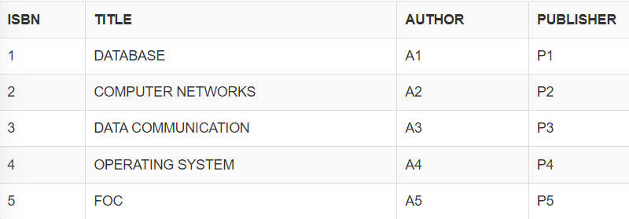

**SELECT * FROM STUDENT1;**

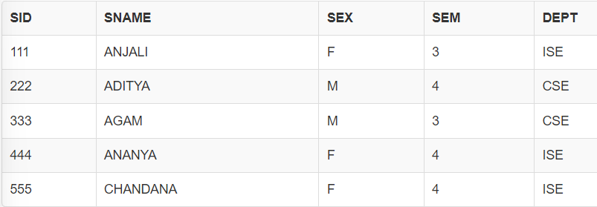

**SELECT * FROM BORROW;**

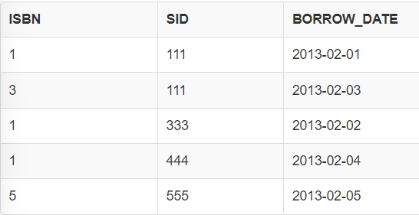

QUESTION 1:-

SELECT SNAME FROM STUDENT

WHERE SID IN (SELECT SID FROM BORROWS

WHERE ISBN IN (123,124));  
  
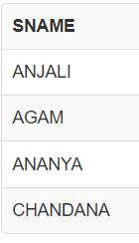

QUESTION 2:-   
SELECT SNAME FROM STUDENT

WHERE SEX ='F' AND SID IN (SELECT SID FROM BORROWS

WHERE ISBN IN (SELECT ISBN FROM BOOKS

WHERE TITLE = 'DATABASE'));

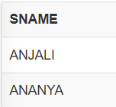

QUESTION 3:-

SELECT B.SID,SNAME,COUNT(ISBN)

FROM STUDENT S, BORROWS B

WHERE B.SID = S.SID

GROUP BY B.SID;

